*************************************************************************************
FACULTY PROFILE
*************************************************************************************
Name of the FacultySAF | Mr. Britto Martin Paul Naricetti |  | 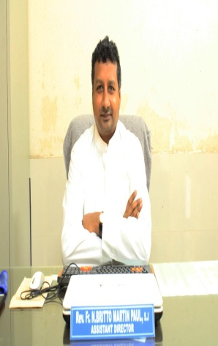
Designation | Principal
Department | Electronics & Communications Engineering (ECE) |  | Date of Birth  28/05/1979
Date of Joining the Institution | 07-07-2022 |  | Native place  Guntur, AP, India
Academic Qualification with Class/Grade
- PG : M.Tech (ES) CGPA & SGPA 10
from MREC (Autonomous), Affiliated to JNTUH.
- UG : B.Tech (ECE) First Class with Distinction from CJITS, Jangaon Affiliated to JNTUH.
- UG: B.Sc (MPC) First Class with Distinction
From ALC (Autonomous), Vijayawada.
- B.Ph: First Class from Jnana Deepa Vidyapeeth, Pune.
- B.Th: First Class from Vidyajyothi college of Theology, Delhi.

Professional Qualification | - Worked as Vice-Principal in Loyola Polytechnic (YSRR), Pulivendla during the years 2010-2011 and 2017-2020 and Boys Hostel Director at Pulivendla during the years 2018-2020.  - Ordained as a Priest in the tradition of Roman Catholicism on 8/11/2014. Member of Andhra Province belonging to Society of Jesus.
Employee ID
E-mail / Mobile | brittomartinsj79@aliet.ac.in , brittomartinsj@yahoo.com  +91 8008899480
Total Experience in Years | Teaching: 05 years | Industry | Research : 01
Papers Published in Journals - | UGC – 2  A Peer-Reviewed- | Articles in Books: 0
Faculty Development Programmes attended: | 02 | Guest Lectures Delivered: 0
Papers presented in Conferences/ attended | National: 01 | International: 01 / Workshops: 02
Are u a PhD Guide? If Yes, Give field & University | Field: ---
PhDs / Projects Guided | PhDs : 00  MPhil -00 | Projects at PG Level : 00
 |  | Projects at UG Level: 02
Books Published/IPRs/Patents | NIL
Professional Memberships | NIL
Editorial Board Membership | NIL
Board of Studies Member: | Yes
Foreign Projects | NIL
National Project | NIL
Grants fetched | 00
Awards - 0
Conferences/ Seminars / Workshops / FDP Organised @ ALIET

Any Other Achievements
Other Responsibilities | Assistant Director @ ALIET,  Director of Gogineni Hostel
Whether Ratified by University (Yes/No) | No
Faculty Development Programmes attended:
- Attended an FDP AICTE sponsored short-term course on ‘Combining hydrology and hydrosocial: Towards comprehensive understanding of river systems’, at IIT, Kharagpur from October 23-29, 2017.
- Attended an GOI sponsored FDP at CeNSE on ‘Advanced Training Program on Nanofabrication and Characterization Techniques’ a hands on training at IISC, Bangalore from March 13-18, 2022.
Online Webinars Attended:
- Attended INUP-i2i Familiarization Workshop on Nanofabrication Technologies in the online mode from 20-22 December, 2021 organized by CeNSE, IISC, Bangalore sponsored by MeitY, GOI.
List of Publications in Journals

- “Surveillance and Estimation of the Crop using Quadcopter”, in IJSER.
(ISSN: 2229-5518) Volume 8, Issue 2, February-2017.
- “ A Zynq Evaluation and Development board based Z-Quad for Precision
Agriculture”, in IJEER. (ISSN: 0975-6450) Volume 9, Number 4 (2017) pp.527-543.

